16720 Computer Vision Assignment 2

Kai Ge

Q1.1

1. There are four types of filters defined here.

Box filter: The box filter realizes to blur the image by changing the value of each pixel to the average value of the surrounding pixels.

Gaussian filter: A Gaussian filter gives less weight to pixels further from the center of the window. The Gaussian filter smooth the image with different intensities. This filter is going to pick up the value of surrounding pixels of each pixel, and assign different weight to adjust the value of each pixel to realize the blurring of the image.

Derivative filter: The Derivative filter if the first order filter and is aimed to find the edges in the image. It computes the derivative of discrete pixels value and find the edges of the image.

Laplacian filter: The Laplacian if Gaussian filter is the second order filter and is aimed to find the edges in the image. Compares to the last filter, the zero crossing of Laplacian filter are more accurate at localizing edges.

Q1.2

The name of the original image is “sun_bnsrnpeqactqrcuy.jpg”.

The original image:



The image generated by the first filter:



The image generated by the tenth filter:



The image generated by the twentieth filter:



The Lab color space describes images mathematically also in three dimensions. L is for lightness and a and b for the color opponents green-red and blue-yellow. In this color space, the lightness L closely matches human perception of lightness. It can be used to make accurate color balance corrections by adjusting a and b components.

Q1.3

Under the condition with k = 0.05 and α = 500, the results of 3 pictures got from the getHarrisPoint function are shown here:







Q2.1

The order of the image is original image, the random dictionary result and the harris dictionary result.



















From the results attached above, the harris dictionary shows better results obviously. The reason is harris function can capture the corner of the objects in images accurately and then it can describe the image more accurate in visual words, that is the reason why the harris dictionary shows a better result.

Q3.2

Recognition result with Harris dictionary and Euclidean method:

The accuracy is 0.443750, the confusion matrix:

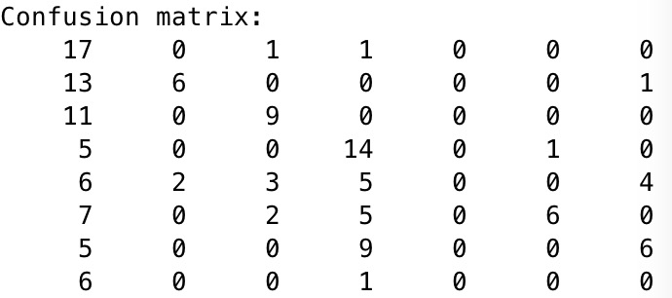

Recognition result with Harris dictionary and Chi-square method:

The accuracy is 0.550000, the confusion matrix:

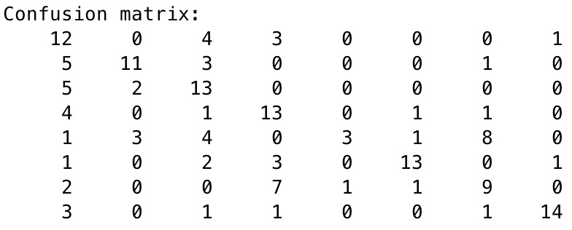

Recognition result with Random dictionary and Euclidean method:

The accuracy is 0.468750, the confusion matrix:

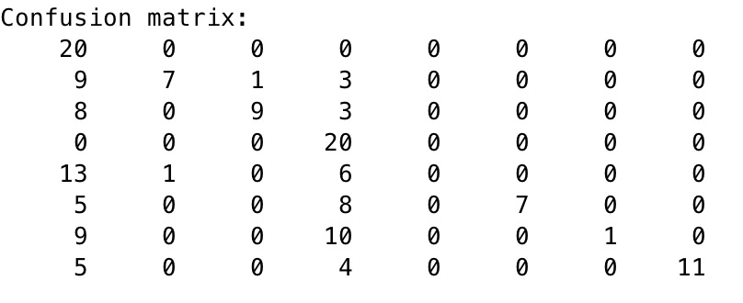

Recognition result with Random dictionary and Chi-square method:

The accuracy is 0.625000, the confusion matrix:

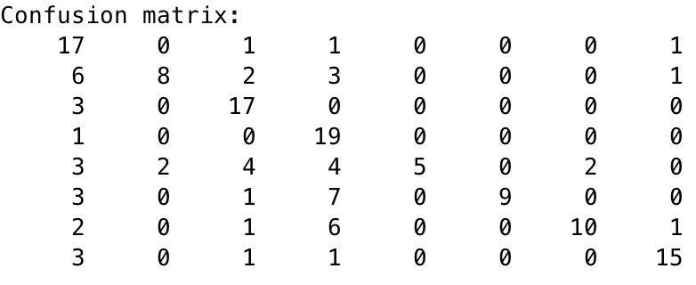

Conclusion:

The accuracy of these four different confusion matrices is attached in the table below:

|  |  |  |
| --- | --- | --- |
|  | Harris Dictionary | Random Dictionary |
| Euclidean | 0.443750 | 0.478750 |
| Chi-square | 0.550000 | 0.625000 |

From the table above, when we compare the results based on dictionary column, the result is obvious that the accuracy of Random Dictionary is higher than Harris Dictionary. Under Euclidean distance method, the accuracy of Harris Dictionary is 44.4% and the accuracy of Random Dictionary is 47.9%, in which condition Random Dictionary shows slightly better than Harris Dictionary. And under Chi-square distance method, the accuracy of Harris is 55% and the accuracy of Random Dictionary is 62.5%, in which condition Random Dictionary shows better performance over Harris Dictionary. The result is beyond initial expectation since the word map of Harris Dictionary showed better performance because it can catch the features of the image better.

Concerning to method calculating method, we can see that the accuracy is 44.3% by Euclidean method while the accuracy is 55% by Chi-square method by using Harris Dictionary, in which condition the Chi-square method shows obvious progress in accuracy. At the same time, the accuracy is 47.9% by Euclidean method while the accuracy is 62.5% by Chi-square method by using Random Dictionary, in which condition the Chi-square method still shows great performance over Euclidean method. Actually, the Chi-square method is built based on Euclidean method, it’s really similar to Euclidean method, but it is doubly weighted by variable and sample unit totals. This measure accords high weight to species whose total abundance in the data is low. It thus tends to exaggerate the distinctiveness of samples’ several rare species. In other words, the Chi-square distance methods is somewhat superior than Euclidean method.